**LAB PROGRAM DAY 7**

**1. Remove Element**

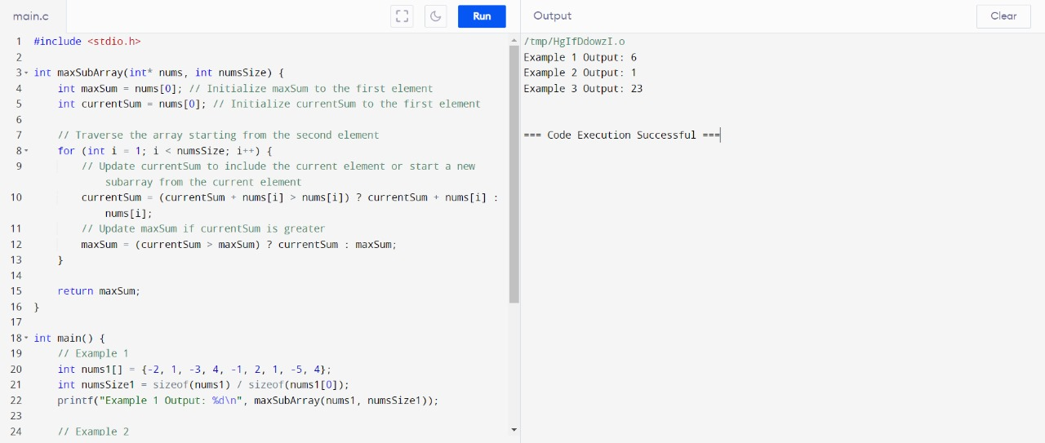

**2. Sudoku board**

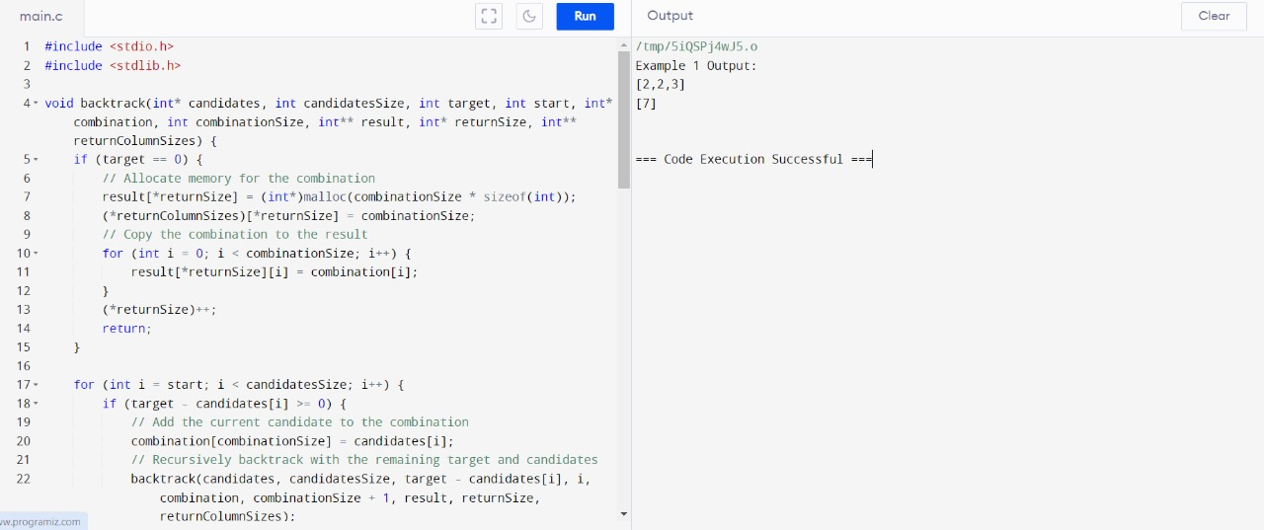

**3. . Sudoku Solver**

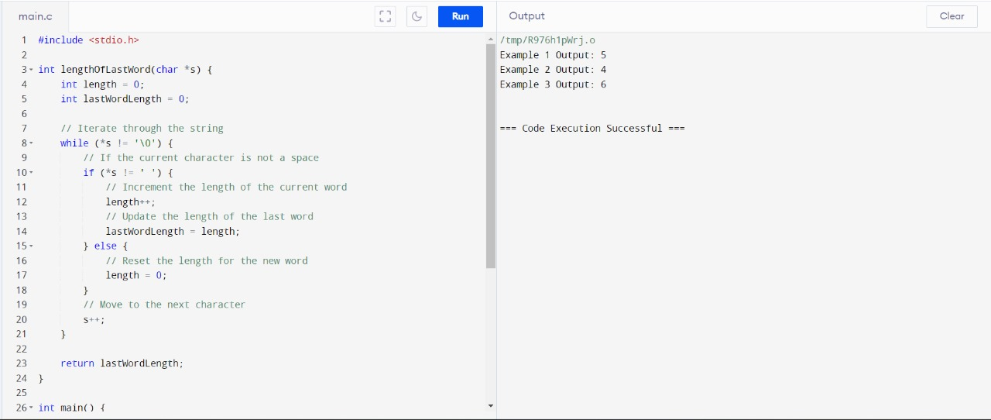

**4. Count and Say**

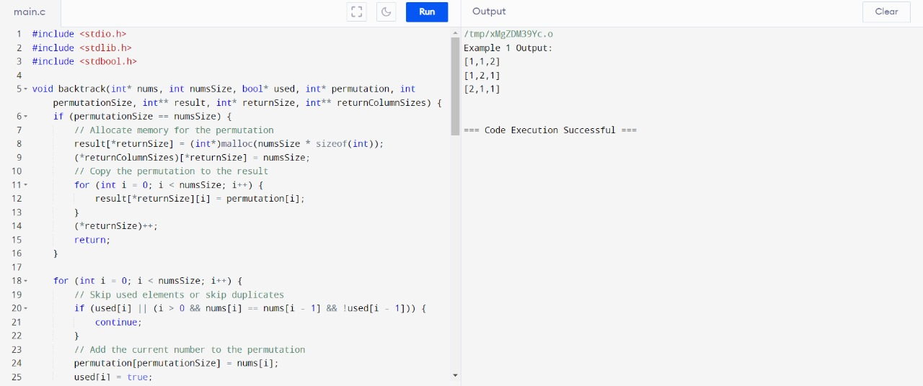

**5. Combination Sum**

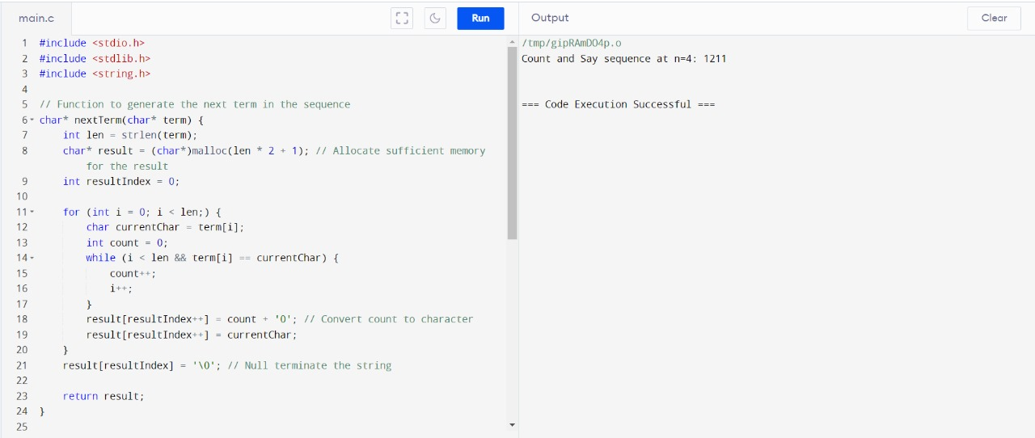

**6. . Combination Sum II**

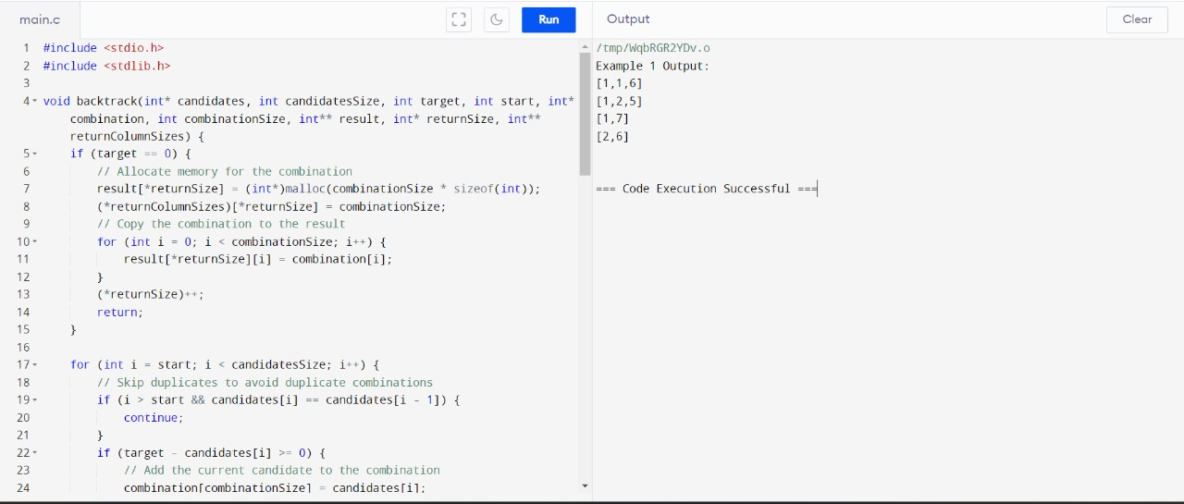

**7. Permutations II**

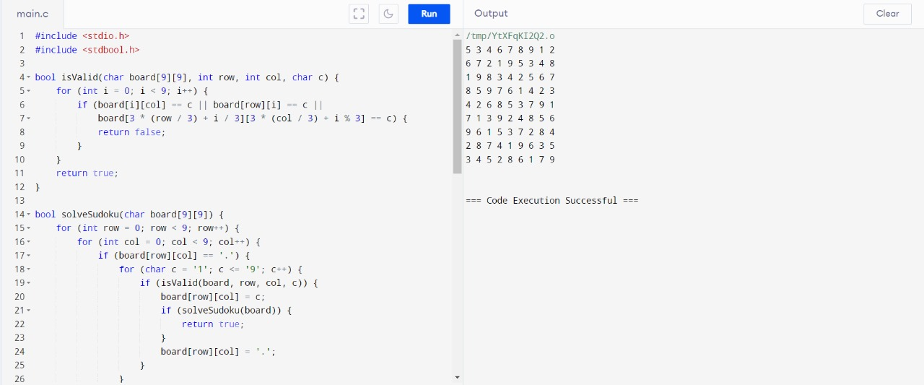

**8. Maximum Subarray**

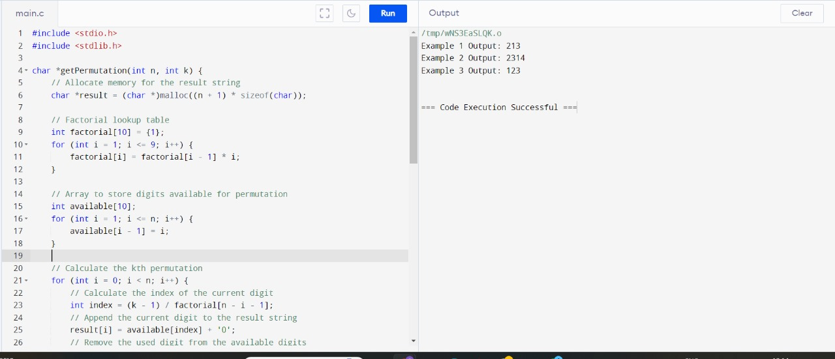

**9. Permutation Sequence**

